Highlighted blue- We are not sure what the question is.
Highlighted yellow- Correct Answers.
Highlighted Red- Mostly agreed that the answer could be supra-marginal gyrus.

EMI
Half life more than 50 h single dose (? Referring to Fluoxetine/Aripiprazole)

SE paroxetine- sweating; amenorrhea; QTC prologation

SE Li- worsening psoriasis, polyuria, hypothyroidism, interstitial nepheritis
SE Topiramate- weight loss; nehprolythiasis; word finding difficulties
Selective D2 antagonist- amisulpride; asenapine; chlorpromazine; respiridone
Partial Mu agonist- bupronorphine
MOA of Pregablin- alpha-2-delta subunit of voltage-gated calcium channels.

Lamotrigone- Voltage gated Na channels

Inhibit aldehyde dehydrogenase- disulfiram
Zopiclone- alpha 1 subunit of omega 1 GABA A receptor

Glycine- at NMDA receptor (interneurones produces glycine to inhibit overstimulation by glutamate)

EMI Ideational apraxia unable to follow sequences (unable to make a cup of tea)
EMI Ideomotor apraxia – unable to utilise tools (use of an hammer)
EMI Unawerness one side of body- hemisomaltagnosia

EMI : A Rogerian psychotherapy developed by incorporating the Beck’s analytic therapy?
A. Cognitive therapy ???
B. Behaviour therapy ???
C. Analytic therapy
D. DBT
E. Rational emotive therapy
F. Group therapy
G. Cue therapy
H. 12-step program
I. Alcohol Anonyms

EMI: During substance abuse therapy, Alcohol or substance signifier is used in controlled conditions?
A. Cognitive therapy
B. Behavior therapy
C. Analytic therapy
D. DBT
E. Rational emotive therapy
F. Group therapy
G. Cue therapy ???
H. 12-step program
I. Alcohol Anonyms

EMI: During substance abuse treatment, people believe that they are helpless, hopeless and powerless?
H. 12-step program

EMI Incongruence between action and gesture – paramimia
EMI a misuse of gestures in expressing thoughts or words that produce an appearance of inappropriateness of affect- Parathymia

EMI Postural hypotension- alpha 1 adrenergic antagonist
What makes people eat less released by duodenum/jejenum – Cholecystokinin.
What is released by hypothalamus and stimulates appetite- neuropeptide Y.
Gherlin from the stomach induces appetite,
Leptin from adipose tissue suppresses appetite.

The feeding center is at lateral hypothalamus
The satiety center is the ventro-media hypothalamus.

Motor cycle accident paralyzed one limb conversion

The woman with multiple gynaecological, gastric pain…for 10 years , all tests normal, convinced drs missed something-? Hypochondriasis

Trinuceotide repeat- fragile X (CGG)
Defective Purine metabolism- Lesh Nehan syndrome
Multifactorial autism
Tau mutation- seen in familial AD sporadic AD Frontotempiral dementia
(Tauopathies – MAPT chrom17; Progranulin chrom 17; Cr9or72; Alpha synuclein chrom 4;

AD: APP amyloid precursor protein chrom 21; presenilin 1 chrom 14; presenilin 2 chrom1 (the APP and presenilin are for early onset dementia)
APO E 4 chrom 19 (this is for late onset dementia).

Tardive dyskinesia- D2 supersentivity.
(other hypothesis are GABA insufficiency, free radical induced neurotoxicity)
Akathisia- D2 occupancy.

Dysbnidin on chrom 6 and Neuregulin gene on chrom 8 are associated with schizophrenia.
COMT on chrom 22 is also associated with schizophrenia.
Trisomy 18- Edward syndrome
Astrocytes channel glutamate (they mop them up).
Use glutamate as nuerotransmitter- pyramidal and granular neurons
Efferent from cortex is via pyramidal neurons

Protest despair detachment maternal deprivation Bowlby theory of attachment ???

Preconcventional conventional post is from Kohlberg theory
Using saline pads- Transcranial direct current stimulation
Stimulate cranial nerve 10- Deep Brain Stimulation (electrodes placed under the clavicle).

Rogers and beck cbt techniques combined
Cognitive therapy motivitional interview????

ICD11 واحده كبيره واتعرضت ل abuse وبتفتكر حاجات من الماضي خصوصا اما بتروح البيت complex pTSD
(ICD11 old lady remembering something from past abuse- complex PTSD)

Child 18m in care institution dosn’t seek out when injured
-Reactive attachment disorder ???

طفل صغير ١٨ شهر اتربي في دار رعايه مش بيحب يروح الحد ولا seek out when injured reactive detachment disorder.

‏ 5y old child who abused, neglect running to social
‏worker and sitting on knee, asking to go home with other parent (easily attached to anyone)?
-Disinhibited social engagement disorder….DSM classification.

طفل ٥ سنين اتعرض abuse neglect بقي في المدرسه يروح social worker use labs w see parents كان عايز يروح معاهم disnhibtion

Parenting style :
High demands with no rigidity with responsiveness- Authoritative
Low self esteem low competence- Seen in a child of an Authoritarian parent
Phylisophy principle

EMI Utilitarianism-
Choosing group therapy over individual therapy because it will help a larger group - Utilitarianism
Pt on clozapine agranulocytosis so the Dr decide not to prescribe it again- non-maleficence
Pt lung cancer after X ray- paternalism (? Dr did not disclose that patient had lung cancer but went ahead and decided on treatment).

MCQ

Puloripotent stem cell at what age -2nd trimester

Cariprazine- partial D3 agonist
Least sexual SE- Vortixetine,
Most concentrated in milk- Fluoxetine
Mirtazepine- Antiemetic 5ht3 antagonism.
MoA atomextine- selective noradrenaline reuptake inhibitor
MoA Memantine- non competitive NMDA antagonist
Long acting injection need to test- Zucloprnthixol (high risk of EPSEs), same apply for depot typical antipsychotics.

Metabotrophic receptors crosses the membrane G protein 7 membrane
Long acting opioid receptor antagonist- nalterexone
Caffein action reversed by adenosine agonist
BNZ with important metabolite Diazepam (metabolite is desmethyl-diazepam)
Patient with Li with HTN- best option is atenolol.

Drug absorption constant is independent of- Elimination constant
Muscle rigidity , sweating, confusion in a women just started medication for psychotic depression- halepridol
What medcation partial agonist on nicotine ? Varencline (alpha 4, beta 2 sub unit of nicotinic receptors)

Erickson theory a 22y what stage- intamcy vs isolation (virtue is love range is 19-35yrs)

Kohlberg 12y old is in the pre-conventional stage, (i.e. punsiment & obdedibce)
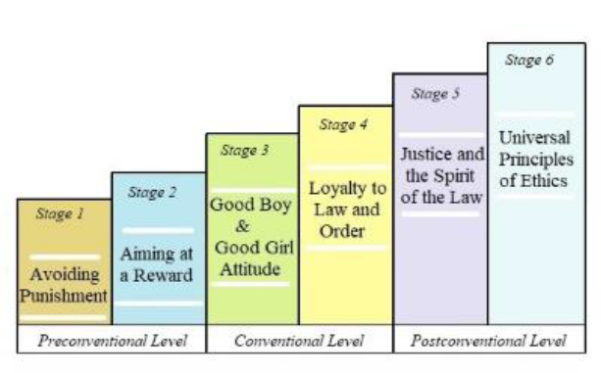
Preconventional 7-12years
Conventional 13-20 years
Postconventional >20years (only 15% have universal principles of ethics).

Wernicks aphasia- Fluent agrammatical and comprehension is not intact.
Broca’s aphasia- non fluent (telegraphic speech) and comprehension is intact.
The area of the brain where noradrenaline is most abundant- Locus’s Ceruolus
(others are acetycholine- nucleus basalis of Meynert; Serotonin- Raphe nuclei; Dopamine- VTA, substantia nigra, acuate nucleus of hypothalamus).

Hormone increase with REM sleep ACH (parasympathetic)
(in NREM sleep noradrenaline increases) (sympathetic)

Neurotransmitter in multitasking- Dopamine.

What is hydroxlation in production of dopamine.
(1st step is the hydroxylation is tyrosine to L-dopa, by tyrosine hydroxylase. It is also the rate limiting step).

What degrade dopamine in presynaptic neurones- Mono amine oxidase.
(MAO B are found in the brain and liver…..MAO A are in the gut).
Seleginine is MAO B inhibitor
Moclobemide is a reversible inhibitor of MAO A

Inattention blindness ? is increased in use of satellite navigator, eating sandwich, text on mobile, call mobile.
The part of brain involved in inattention blindness is prefrontal cortex.

Test need intervewer Hamilton
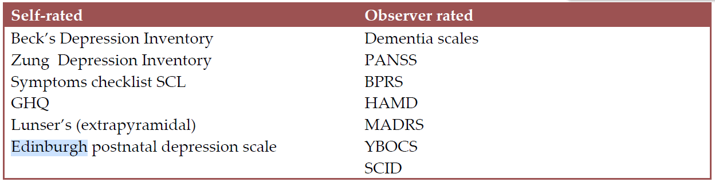

Screening tool- EPDS

ADHD DRD4
Familial Fronto-temporal dementia is tau positive, ubiquitin negative

Autism- Hypoplasia of the cerebellar vermis
ApoE4 homozygous increases the risk of AD by 10-30 folds.
ApoE4 heterozygous is 2-3 folds.

Human prion disease ? Fatal Familial insomnia (FFI) is a example of prion disease, the rest are CJD, variants of CJD, Kuru, Gerstman Straussler scheinker syndrome.
FFI is caused by mutation in chrom 20p13. The gene is PRNP (autosomal dominant disease)
Schiz there is reduction in: Amygdala volume; hippocampus; thalamus, nucleus accumbens, intracranial volume is reduced.
There is increase in lateral ventricles and palidum.
There is reversal of the normal left>right asymmetry of the planum temporale.

PTSD most implicated amygdala
Empathy insula, supra-marginal gyrus and anterior cingulate cortex are involved in emotional empathy. (DLPc occibtal corteX amygdala).
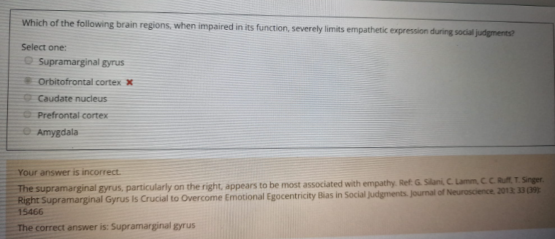

Confabulation
● Can only occur in Korsacoff syndrome
● May occur in clouded consciousness
● There is deliberate falsification of facts
● Autobiographical memory
● There is subjective awareness of memory impairment

Different between complex PTSD&PTSD-
In cPTSD you have “All diagnostic requirements for PTSD are met. In addition, Complex PTSD is characterised by severe and persistent 1) problems in affect regulation; 2) beliefs about oneself as diminished, defeated or worthless, accompanied by feelings of shame, guilt or failure related to the traumatic event; and 3) difficulties in sustaining relationships and in feeling close to others. These symptoms cause significant impairment in personal, family, social, educational, occupational or other important areas of functioning”.
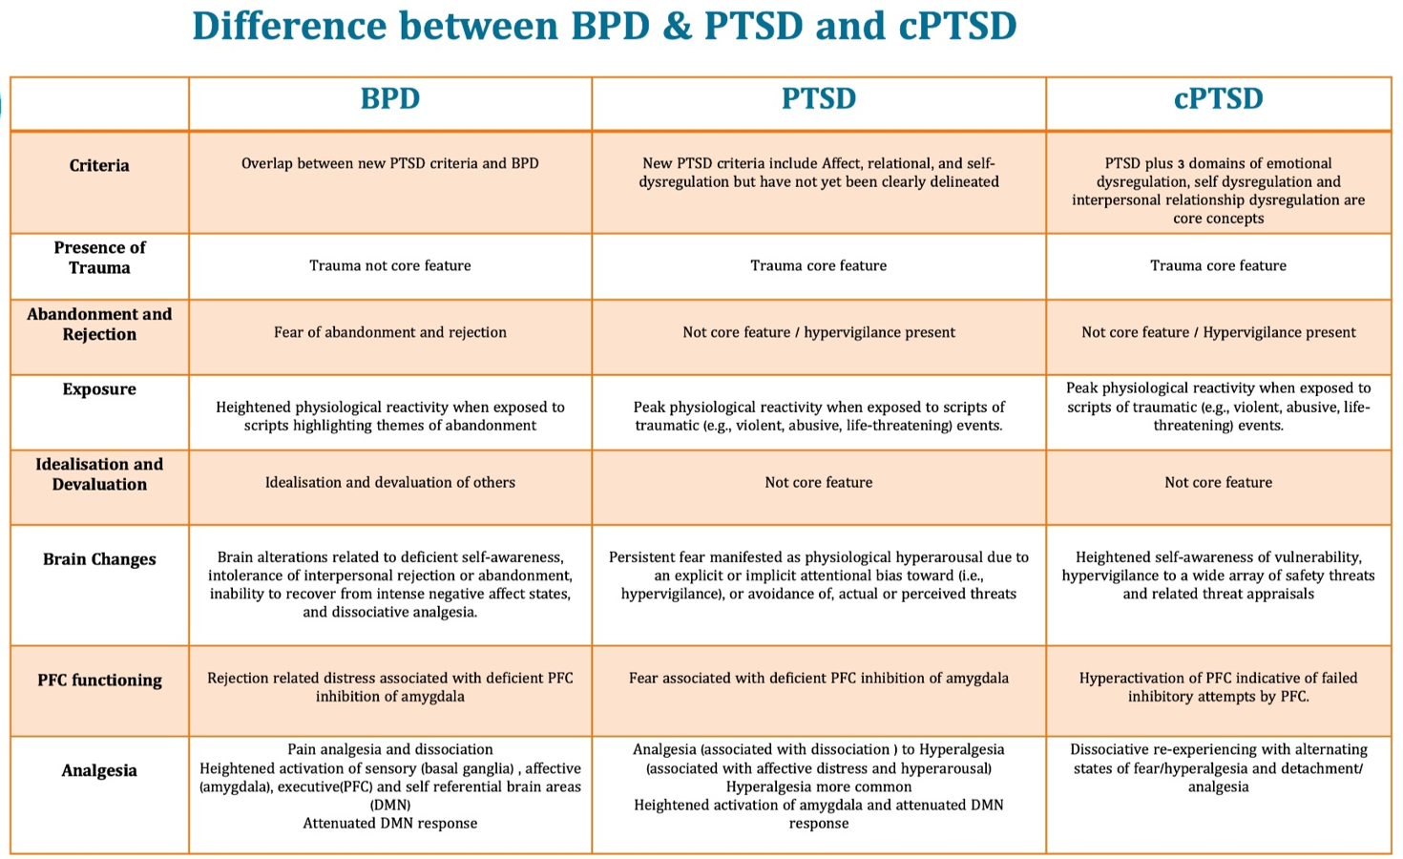

Different between food restrict disorder &anorexia
In anorexia there is preoccupation with weight and body image distortion.

ICD11 criteria difference between mania and hypo mania
(there seems to be no change from ICD 10. The difference is severity and duration).

Reciprocal inhibition is seen in systemic desensitization
Parkinson’s disease resting tremor- 4to6 Hz (pill rolling tremor is 3-4Hz)

Conrads stages of model of beginning of schizophrenia
Person find interpretation (meaning) to psychosis- Apophany
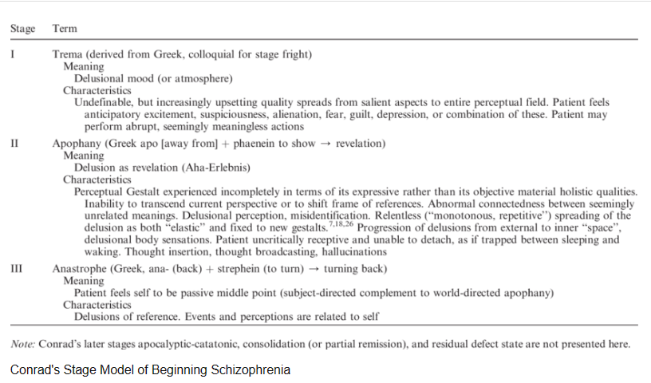

Preserved in schiz- procedural memory (working memory is most affected)
Anti-inflammatory cytokine involved in depression- IL6
Component of ORIGINAL Maslow hierarchy of needs- self esteem
Concrete operation know the size of 2 ball although at different distance

Rat not walking on regions free of electric shock what learning is this - avoidance learning
What can be done to reduce group think- open debate/ devil’s advocate/ leader speaking last/ seeking external opinion/ holding last chance meeting.

Popularity more ? Early Mature femal mature elderly more advanced
Male with their peer less confident family birth order

Last part of the brain to mature- ant frontal pole (specifically DLPFC, not fully mature until age 25).
Heretability definition- Genetic contribution to phenotypic variation
9 times more incidence of schizophrenia in African carbiean- migration
Delay development language is least contributing factor- small family size
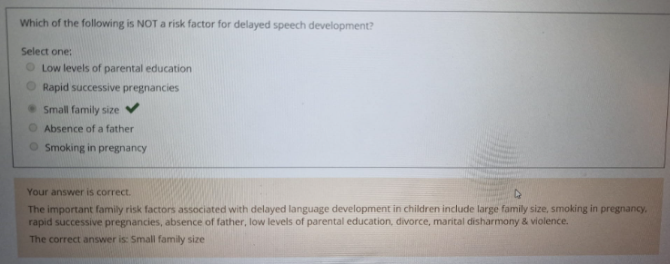

Independent on
Area under curve- bioavailability
In 1st order kinetic area- constant fraction of drug being eliminated.

People need leader (i.e type of leadership).

Pedigree Autosomal Dominant.
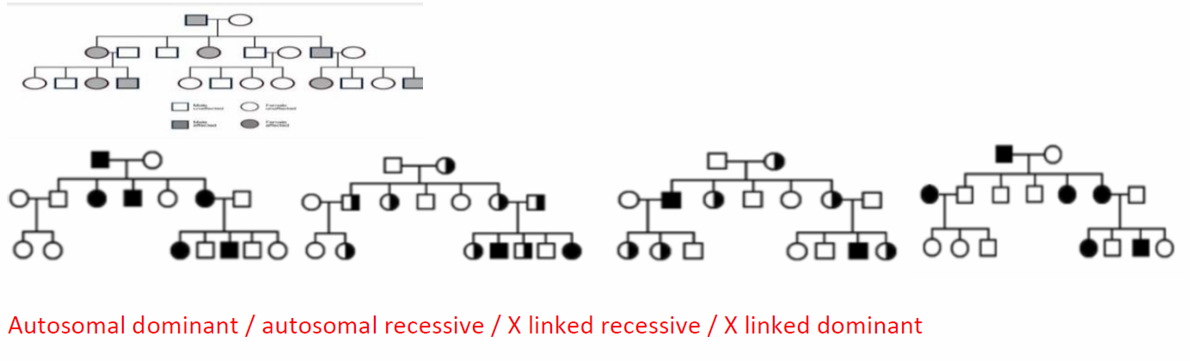

Research volunteering in old age

Strop test- selective attention
Cocktail party phenomena- selective auditory (auditory funnel theory).

Highest form attention is divided attention.

Focused attention - change attention

9 dimensions of temperament.

New York Longitudinal Study is a key study on childhood temperament conducted by Thomas
& Chess. It is a thirty years (initially 6 years) longitudinal study of 138 children, observing
childhood temperaments. It employed parental interviews to ascertain temperamental
dimensions – 9 such dimensions have been used:

1. Activity
2. rhythmicity
3. approach/withdrawal
4. adaptability
5. intensity
6. threshold
7. mood
8. distractibility
9. attention span / persistence

Three behavioural styles were identified using the above 9 dimensions
1. Easy – rhythmic pattern of needs, adapts well, and active – 40%
2. Difficult – less predictable, uncomfortable with new experiences, negative mood, react
intensely to stimuli, difficult to comfort – 10%
3. Slow to warm up children – adapts poorly to change, but less active and responds at
low intensity – 15%
4. Ungrouped – 35%
Difficult temperament may offer some survival benefits as mother pays more attention –
especially in tribal populations. Inhibition (approach/withdrawal dimension), according to
Keagan, is a strongly inborn trait. Behavioural inhibition may be a precursor for later neurotic
disorders including anxiety and depression. In an extreme form of inhibition called neophobia, a
child appears frozen and withdrawn in novel situations.

What is correct about Bullying- bullying increase transition primary to
secondary bullying more in female bullying on the teacher. (Unsure of question been asked here).

How does aggression decrease-
-When the observer to aggressors punishing
-Challenging the thoughts of the aggressor
-nonaggressive responses to a situation

Most important pathophysiology for alzheimers- Neurofibrillary tangles (are the earliest changes and the most important).
- Neurofibrillary Tangles and Hirano bodies are intracellular.
- Amyloid plaques are extracellular.
- (incase it is asked NFT and Hirano bodies can be found extracellularly when neuronal cell dies).
Lewy bodies and Pick bodies are intracellular.

Default network (in introspection, quiet thinking)- medial prefrontal cortex /angular gyrus / posterior cingulate cortex/ precuneus (MAPP)
Salience (switching between default network to focusing mode)- Frontal operculum/ Anterior insula/ Dorsal anterior cingulate cortex/ Anterior pre-frontal cortex. (FADA)
There are also subcortical structures of the ventral striatum involved in Salience network.
Central executive network (needed for deep concentration)- Frontal gyrus/ Lateral superior parietal lobe/ Intraparietal sulcus/ Dorsal lateral prefrontal cortex. (FLID)

Congenital malformation associated with sodium valporate 8-12%
HIV with encephalitis presenting with cognitive impairment, what is the next step- commence anti-retroviral.

Most reliable indicator with myocarditis-
Eosinophilia is the most reliable indicator (however only from myocardial biopsy). Blood test for Troponin I/T should be done.

Adding new information in existing schema- Assimilation.
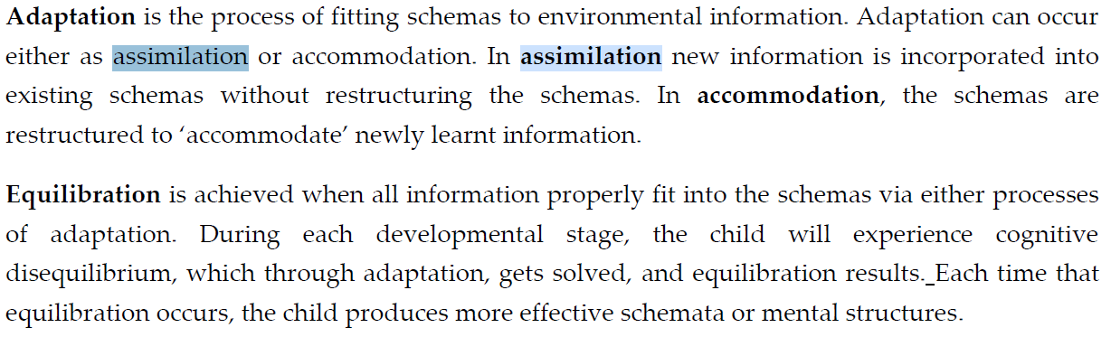

Moved to the UK, speaks english at work, at home he retains his culture, religious, family matter- Bicultrulism/ Integration.
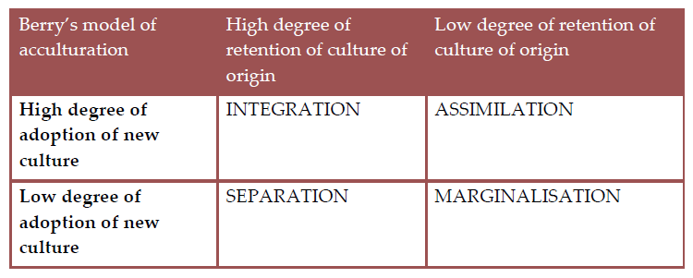

Sally Anne test- theory of mind

Attachment (which is true)- Attachment occur in all culture

Q association study (? Question on this)- Was developed by William Stephenson.
It is a systematic study of participants viewpoint/suggestibility.

“The Q-sort technique developed from client-centered therapy involves a person sorting cards with self-descriptive statements(e.g. ‘I don’t trust my own emotions’, ‘I like to be around friends’) on them into ordered piles under the headings ‘self’ and ‘ideal’. A numerical discrepancy score between ideal and real self can be thus computed”.

Rate limiting enzyme in alcohol metabolism – alcohol dehydrogenase.

During interview a doctor offered hand shake to a schizophrenic patient. Patient move forward and then withdraw hand for 20 times – Ambitendency.

Hawthorne effect- Performances changes under observation.
Halo effect (angel’s halo)- Perceiving people as good (this person smiles they must be good person)
Horn effect (devil effect)- Perceiving people has been bad due to an attribute (person not smiling so they must be bad).
Reserve Halo effect- Perceiving a positive attribute to a negative one (e.g. a person is smiling and you think they must be mischievous)

patient can be positioned in uncomfortable postures, with resistant tone which are maintained for a considerable period of time. Waxy flexibility (i.e catalepsy)
(for waxy flexibility, an external pressure is being applied. For posturing, the patient assumes a position spontaneously. Psychological pillow is an example of posturing)

Advantage of prospective study ??

According to ÆSOP study, what accounts for the nine-fold increased risk of schizophrenia in patients of African-Caribbean descent? = immigration.

Depression learned helplessness forced swim test

Sally Anne test what- Theory of mind
Attachment
Attachment occur in all culutue
Q association study
EMI 12 step powerless
EMI Cue exposure
Rate limiting enzyme in alcohol metabolism – alcohol dehydrogenase
During interview a doctor offered hand shake to a schizophrenic patient. Patient move forward and then withdraw hand for 20 times - Ambitendency
Hawthorne effect
Halo effect
patient can be positioned in uncomfortable postures, with resistant tone which are maintained

Which Hormone is expressed in the mother whose mother show good interaction with – oxytocin.

Tract white matter track- DTI (Diffusion Tensor Imaging)

When used MRI what ‘s signal ? Hydrogen ion (MRI uses the water content of the tissue being viewed)

Alcohol more than limited dose craving ? Alcohol use disorder alchol dependence syndrome harmful use

DSM5- schizophrenia subtypes were removed.

Criteria for Delusional Disorder? No persistent hallucination
ICD 11: “Delusional disorder is characterised by the development of a delusion or set of related delusions, typically persisting for at least 3 months and often much longer, in the absence of a Depressive, Manic, or Mixed mood episode. The delusions are variable in content across individuals, but typically stable within individuals, although they may evolve over time. Other characteristic symptoms of Schizophrenia (i.e. clear and persistent hallucinations, negative symptoms, disorganised thinking, or experiences of influence, passivity, or control) are not present, although various forms of perceptual disturbances (e.g. hallucinations, illusions, misidentifications of persons) thematically related to the delusion are still consistent with the diagnosis. Apart from actions and attitudes directly related to the delusion or delusional system, affect, speech, and behavior are typically unaffected. The symptoms are not a manifestation of another medical condition (e.g., a brain tumour) and are not due to the effect of a substance or medication on the central nervous system (e.g. corticosteroids), including withdrawal effects (e.g. alcohol withdrawal).”

Bodily distress disorder- In ICD 11; it is under Disorders of bodily distress or bodily experience.

ICD11 most accurate Gaming disorder: New ICD11 classification, under disorders due to addictive behaviours (same for gambling)

Gaming disorder is characterised by a pattern of persistent or recurrent gaming behaviour (‘digital gaming’ or ‘video-gaming’), which may be online (i.e., over the internet) or offline, manifested by: 1. impaired control over gaming (e.g., onset, frequency, intensity, duration, termination, context); 2. increasing priority given to gaming to the extent that gaming takes precedence over other life interests and daily activities; and 3. continuation or escalation of gaming despite the occurrence of negative consequences. The pattern of gaming behaviour may be continuous or episodic and recurrent. The pattern of gaming behaviour results in marked distress or significant impairment in personal, family, social, educational, occupational, or other important areas of functioning. The gaming behaviour and other features are normally evident over a period of at least 12 months in order for a diagnosis to be assigned, although the required duration may be shortened if all diagnostic requirements are met and symptoms are severe.

Superstition theory of OCD immediate relive anxiety after compulsion displacement thoughts DM to decrease it

Standard deviation for intellectual disability in icd11- Two or more standard deviations below the mean (approximately less than the 2.3rd percentile).

D2 receptor in one Reserach in Extapyramidal symptom .2 .4 .5 .6 .8

CATIE risk of metabolic syndrome: 41-50% (51.6% for females/ 36% for males).
CATIE risk of type 2 diabetes mellitus (19-30%).

